Arcadia’s Natural Values community workshop: 18 November 2018
Presented by Geoffrey Bay Coastcare
Draft Minutes
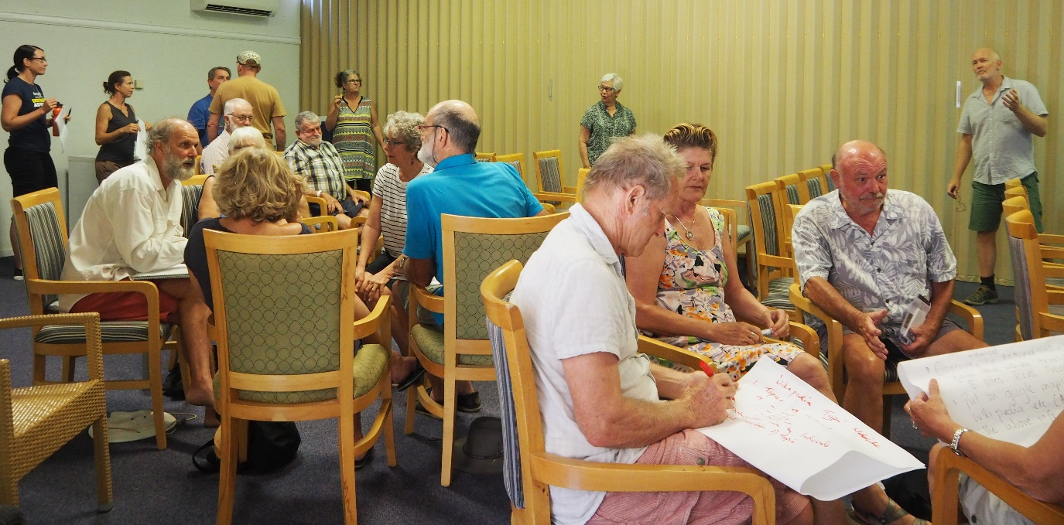
Agenda
10.00 Introduction
10.20 Identifying and describing natural values on public land at Arcadia
10.40 Methods for presenting Arcadia’s natural values to locals and visitors
11.00 Your suggestions for describing and presenting the values
11.25 Your preferred values and presentation methods
11.50 Next steps: pathway to project completion
12.00 Close

Attendees:
Meredyth Woodward, Jim Thompson, Marie de Monchaux, Tony O’Malley, Vandhana, Beat Lehmann, Audrey Ledbrook, Sara Shaw, Tim Hempstead, Phil & Selina Hale, Prue Smith, Laura Dunstan, Brian Smith, Michael Allen, Rolf Petherbridge, Philip Stevenson, Sue Swaddling, Mark & Jill Taylor, Jenny Terrey, Gethin Morgan, Tania Thoreau, Gary McGill, Hugh Wallace-Smith, Julia Clement, Carla Wegscheidl, Karen Phillips, Charlie McColl, Zoltan Szirom, Les Sampson, Brian Johnson, Julie Woodlock, Lea Scherl
Apologies:
Philip Allnut and Anthony, Bob Flemming, Rick Braley, Jo Petersen, Chris Manning, Thijs Krugers, Cr Anne Marie Greaney, Francis Thomson, Stuart, Adam King
Acknowledgements
- Thanks Arcadia Village Hotel for providing venue free of charge.
- Thanks Meredyth, Vandhana & Beat for helping prepare for the workshop.
- Brian Johnson from Wulgurukaba welcomed us.

Introduction
A slideshow (attached) provided details on the following:
- Geoffrey Bay Coastcare
- National Landcare Program: Environment Small Grant
- Natural values (definition)
- Agenda
- Our criteria for products
- Geoffrey Bay Interpretation project 2016
- 2016 workshop outcomes
- Wulgurukaba consultation 2016
- 2016 workshop outcome

Identifying and describing natural values on public land at Arcadia
A slideshow (attached) provided details on the following:
- Describing Arcadia’s natural values 2018
- Geoffrey Bay foreshore
- Geoffrey Bay Scrub
- Petersen Creek
- Alma Creek
- Alma Bay beach
- Alma Bay headlands
- Jetty Rd
- Gabul Way
- Arcadia hinterland
- Street trees
- Wildlife
- Arcadia’s marine life

Methods for presenting Arcadia’s natural values to locals and visitors (Sara Shaw)
A slideshow (attached) provided details on the following:
- Potential future interpretation
- Existing interpretation
- Snorkel trails example
- 8 launches/tours
Your suggestions for describing and presenting the values (from attendees)
- Why promote the natural areas? Because awareness can help ensure we keep them in good condition.
- A Wulgurukaba knowledge trail.
- What’s in and out of scope? Don’t necessarily agree with separating natural values and heritage, eg the planted Tamarinds are important too. Include old houses too. Why confine scope to public land, eg flying foxes roost on private land? But our Coastcare group has limited capacity; our focus is natural areas on public land. Best to focus on what we can sustain in long run.
- A webpage that shows roles of various island groups and links to other sites, eg link to Magnetic Museum for old houses.
- Re social media, MINCA set up Instagram but are finding it a struggle to maintain.
- Bringing more people to more places can destroy places. Need a solid strategy to preserve. There is danger in making some places public.
- Raise awareness of natural areas with locals, eg impacts of dogs on shorebirds.
- Don’t want a scattergun approach. Need to be clear on who our target audience is; what response from our audience we are seeking and how we monitor effectiveness?
- It’s a rare and beautiful place, particularly Alma Bay & Jetty Rd, and makes us very protective. Council appreciates being thanked for helping look after natural values.
- Look at the geology, geomorphology and land use history. What are we left with after development? There are the parallel dunes at Geoffrey Bay, vine thicket at Geoffrey Bay Scrub, aeolian wind-blown sand dune at Alma, alluvial (not much) to estuarine areas along creeks, red soils on higher areas. Regarding land use history, there were the huts along the front at Geoffrey, early residential development on Olympus Crescent, etc.
- Include National Park walking tracks to Sphinx, Arcadia to Nelly track, etc.
- Consider Lord Howe Island as an example. It has a 25 kph speed limit which is good for wildlife
- Consider social impact to residents, eg of bringing more visitors to certain areas.
- Many meetings are called by Tourism MI, Museum of underwater art, QPWS/Marine Parks, TEL, Sealink, etc. There are so many different entities on the island. This group/meeting is very good. We need better administration on the island, like Lord Howe.

Your preferred values and presentation methods
Attendees broke into five small groups and came up with the following project ideas:
- For visitors, aimed at families and backpackers. Interactive and fun. A trail map to different sites/areas of interest to learn about natural values, what lives there and value of habitat. A treasure map/hunt. You’d pick up a clue sheet with a description and question for each site which you’d tick off and take back to pub or newsagency to get a prize. It might be sorted around themes, eg birds, sea and hinterland connectivity, migrations. Similar to snorkel trail. Launch it via an event. It could be on paper or an app or both. Some people get lost on apps. Are there any apps with geology, maybe Google Earth?
- Increasing/developing awareness of locals. Capture, identify and compile the natural values, stories, context and background of a given area/the whole trail of 8 sites across Arcadia, eg geology, geomorphology, history. Then put all the captured info about places and trail map on Wikipedia-type website and link to google maps. Wikipedia-type website because contributions would be made by individuals with knowledge of the topic. Topics could include trees, birds, animals, trails etc. A trail for locals.
- Focus on the foreshore. Gabul Way and interpreting and linking that to Alma Bay and creating a better link between the two (Geoffrey and Alma) with natural interpretation, not signage. An app and website that can be connected to other websites, eg What’s On natural values of Arcadia. Also a two sided pdf with good scale map and info on back. Start a volunteer roster with guided tours every Sat and Sun from bottom of Gabul Way to specific sites.
- Awareness/communication. Provide information: signage, website, Traditional Owner stories. If material is educational, people become more informed, respectful and appreciative. Use proactive methodologies; promote why places are protected. But maybe some sites can’t be managed for visitors and therefore don’t open them up. Take care of loving the place to death. Focus on where people already go to anyway, i.e. existing traffic areas and manage the visitation there; not opening visitation to new areas. Consider strategic signage for places where people already go to. Provide info on what to do and not to do to minimise impact. Intrepid travelling, respect culture. Traditional Owner values on top.
- A walking trail with a guide. Walking trail in figure 8, crossing at Appian Way & Petersen Creek (beach hibiscus forest), high wind blown sand dune, natural features. Hard copy version (A4 folded in half) of guide and on-line version too. Geriatric tourism is a growing market (who prefer hard copy). Guide should be provided by agents to every short term rental property. Make a small amendment to Magnetic Island Guide page on trails to include Arcadia trail and refer to proposed website. Website to facilitate download of map. Launch with a promotional event.

Next steps
Process for deciding on, producing and launching the product:
- Write up the results of this workshop and share with attendees
- Consult with Wulgurukaba, TCC, QPWS, etc.
- Share consultation results with all, propose product and invite feedback.
- Working Group decide on product.
- Engage consultant to design and produce product.
- Launch product - Invite community, special guests and media. Combine launch with a weed/plant tour and entertainment.
- Monitor and evaluate the success of the product.
- Update interpretation plan.

Closing advice (from attendees)
- Meet with Cr Greaney, MINCA, MI Tourism, MICDA, MIRRA.
- MICDA can help with heritage stuff. Is there a heritage trail linking existing heritage signs?
- Educating schools is important.
- Grade the trails, i.e. provide info on fitness level required.
- Locals want to keep Arcadia the way it is.
- Selina, Julie, Leah, Hugh and Karen to join existing Working Group of Tony, Vandhana, Meredyth and Beat to progress this project.

WORKSHOP END

